**ADM21AJ016-online grocery store**

**Project Abstract**

**Version 1.0**

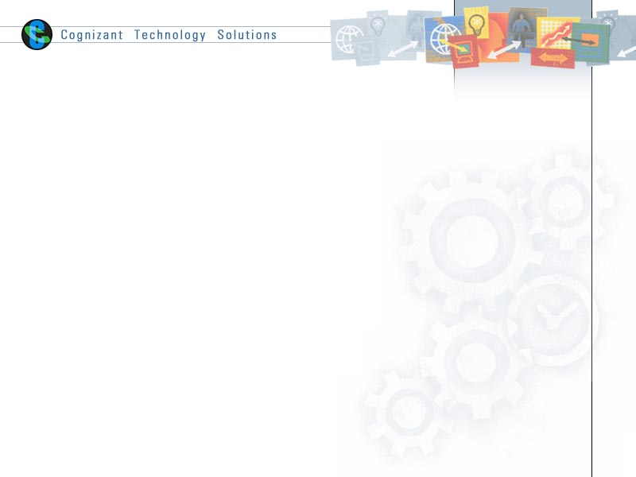

|  |  |  |  |
| --- | --- | --- | --- |
|  | Prepared By / Last Updated By | Reviewed by | Approved By |
| Name | Dighe Riya  Marrivada Shanmukha Sai Kavya  Sumanth Mittapally  Teja Jami  Vaibhav Shetty |  |  |
| Role | Software Developer |  |  |
| Signature | Dighe Riya -2065747  Marrivada Shanmukha Sai Kavya – 2065919  Sumanth Mittapally-2065743  Teja Jami - 2066007  Vaibhav Shetty - 2065774 |  |  |
| Date | 11-02-2022 |  |  |

Table of Contents

1.0 Purpose of this document 3

2.0 Business Case 3

3.0 Appendices 4

3.1 Glossary 4

3.2 Other 4

4.0 Terms & Conditions 5

5.0 Change Log 5

# Purpose of this document

This document provides an overview about the business need and the solution that can be provided to fulfil the objective.

# Business Case

**Abstract**

The Online Grocery Shopping is a web-based application intended for online retailers. The main objective of this application is to make it interactive and easy to use. The purpose of this system is to automate the existing manual system with the help of computerized equipment and full-fledged computer software, fulfilling their requirements so that their valuable data can be stored for a longer period with easy accessing and manipulating of the same. The web-based application helps customer to choose their daily needs and add products to their shopping cart. It permits a customer to submit online orders by searching, viewing, and selecting a product easier. It contains a sophisticated search engine for the users to search for products specific to their needs. The search engine provides an easy and convenient way to search for products where a user can search for a product interactively and the search engine would refine the products available based on the user’s input. The customer will register in the application and move the item to the cart. The user can then view the category of each product. They can also write their own reviews and can also complain. Customers provide their complete detail of address and contact and they get their chosen products in their homes. They can choose the payment method. The web-based application will also show the status of delivery and expected delivery date. This is designed for all the customers to save Time and Cost.

**Technologies to be used:**

* React-bootstrap
* Java
* Spring MVC using Spring Boot
* MySQL database

**Roles/ Users:**

* Admin
* Customer

# Appendices

## Glossary

|  |  |
| --- | --- |
| **Acronyms** | **Definitions** |
|  |  |

## Other

# Terms & Conditions

***Disclaimer: Please do not circulate or distribute this document outside of Cognizant Network, We have a Zero Tolerance Policy. Kindly adhere to 100% Compliance at all times.***

# Change Log

*Please note that this table needs to be maintained even if a Configuration Management tool is used.*

|  |  |  |  |  |
| --- | --- | --- | --- | --- |
| Version Number | Changes made | | | |
| V<n.n> | *<If the change details are not explicitly documented in the table below, reference should be provided here>* | | | |
| Page no | Changed by | Effective date | Changes effected |
|  |  |  |  |
|  |  |  |  |
|  |  |  |  |
|  |  |  |  |